**COMPUTER SYSTEMS SECURITY**

**Lab Session 04**

***Examine Attacks on TCP/IP Protocols***

Name: Syeda Marium Faheem

Roll No: CS-099

Section: B

**Task No.1**

Machine 1



Now change reflect on Machine 2

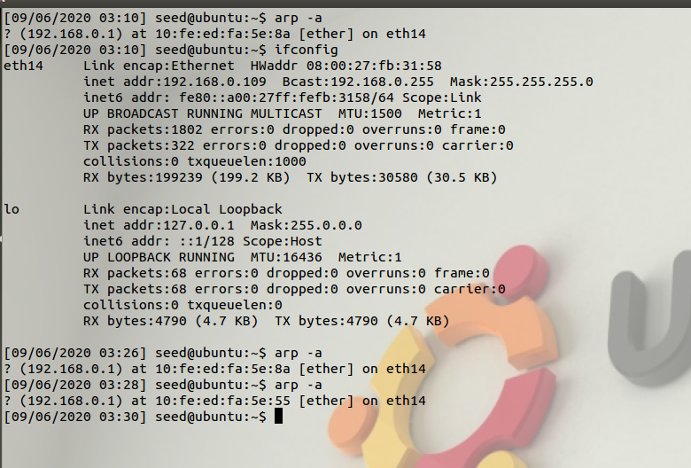

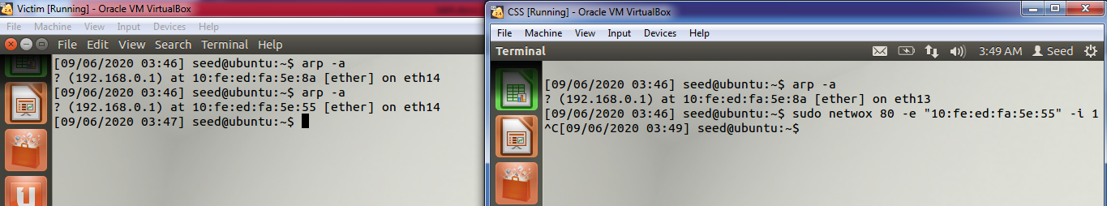

**Task No.2**

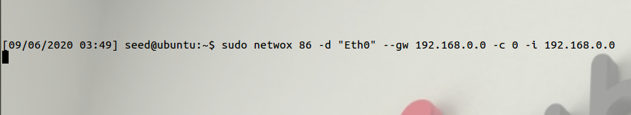

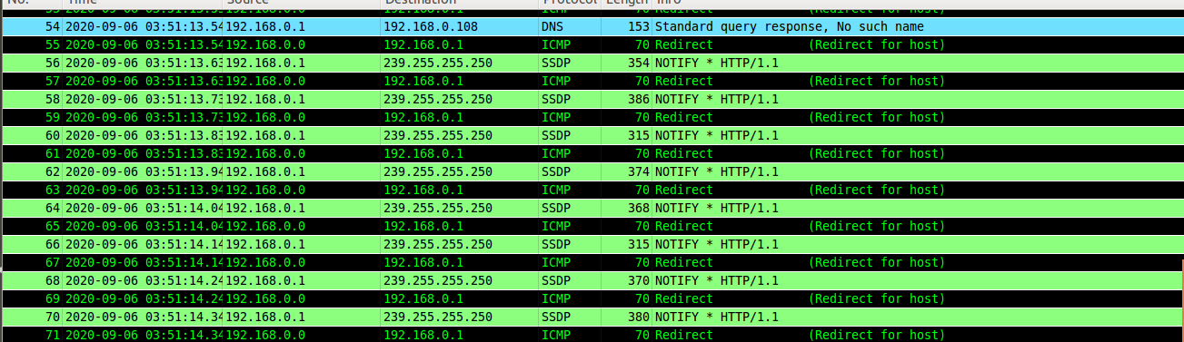

**Task No.3**

Attacker Machine:

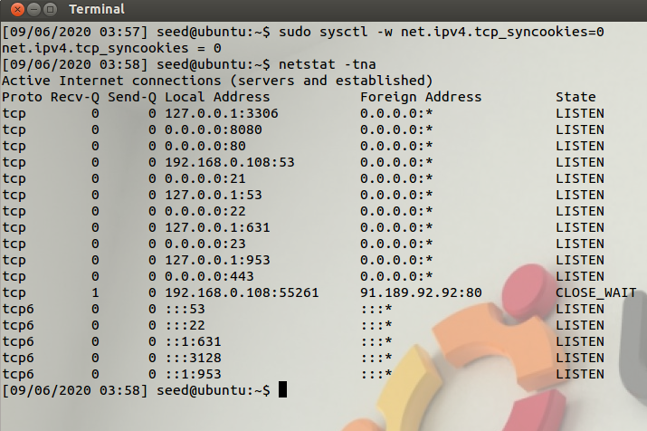

Then run command of netwoxt

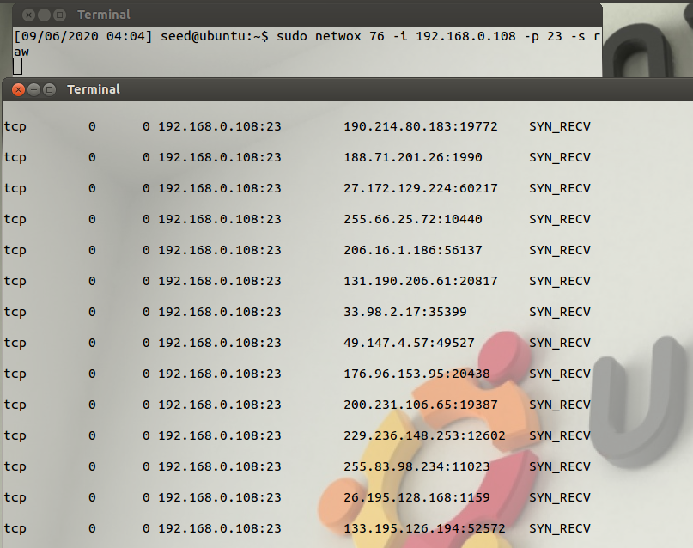

On Client Machine trying to connect but it cant connect because of sysn msg

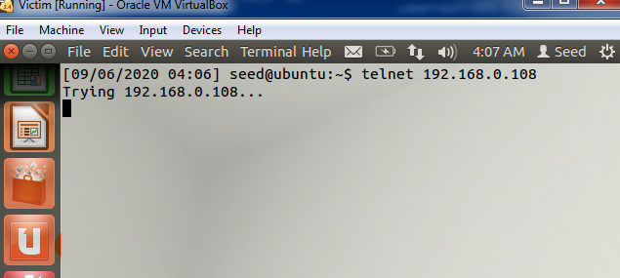

**Task no.4**

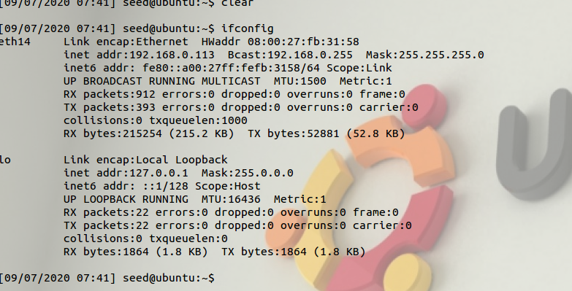

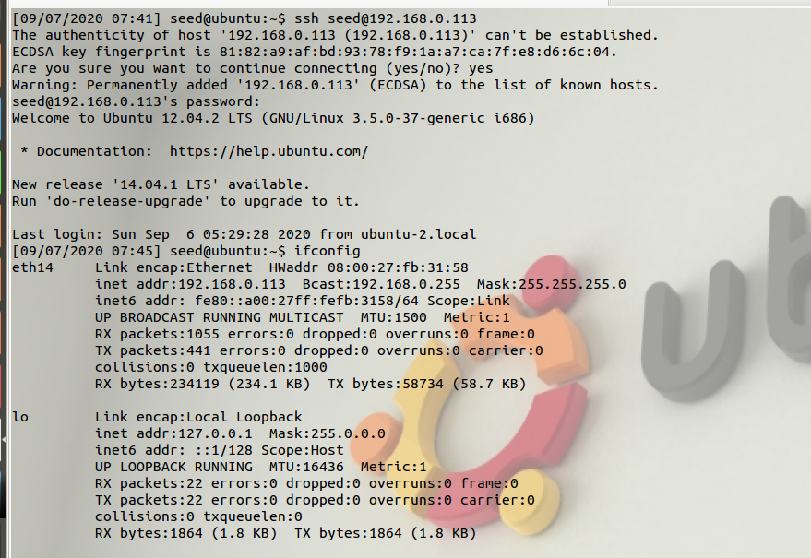**Machine 1 (Login through SSh command in 192.168.0.113)**

Then run command: sudo netwox 78 -i 192.168.0.113

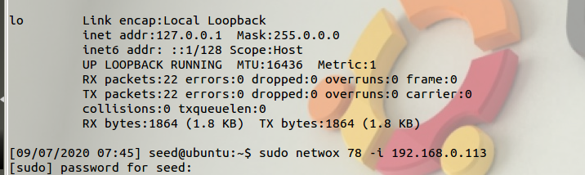

Captured on VM2:filter by (ip.src == 192.168.0.113&&ip.dst == 192.168.0.108) || (ip.dst == 192.168.0.113&&ip.src == 192.168.0.108)

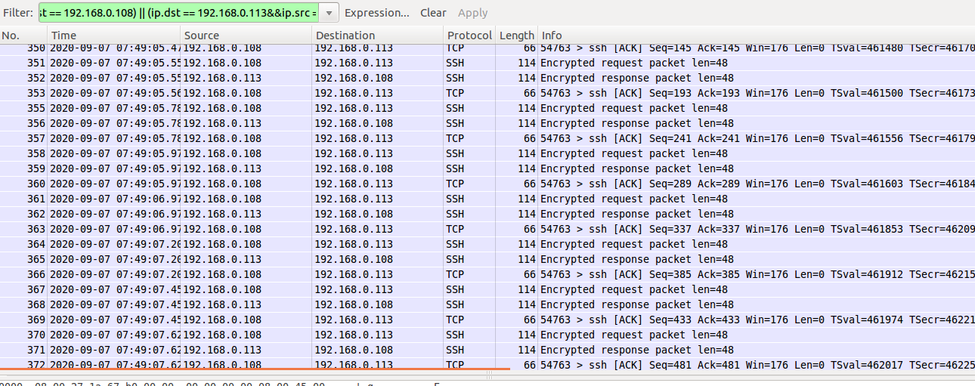

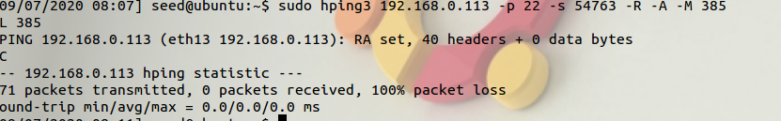

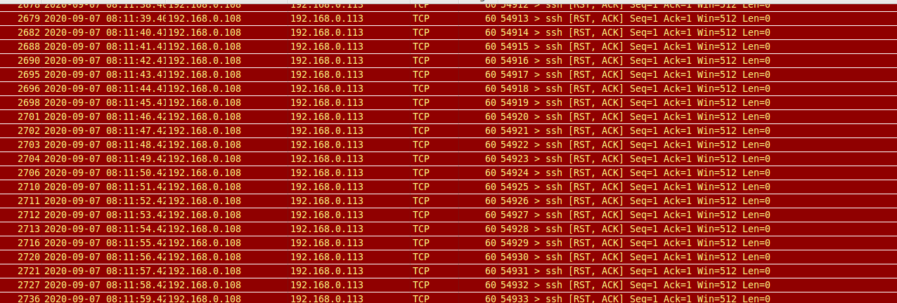

**Task No.5**

